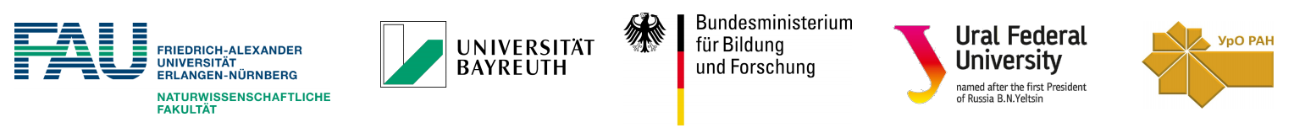

7th German - Russian Travelling Seminar "Nanomaterials and scattering methods"
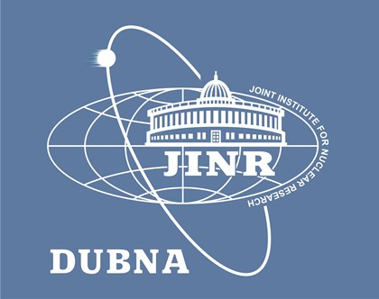
Visit to Joint Institute for Nuclear Research
(September 18th, 2017)
Program:
09:00 – 09:15 | Deputy director of FLNP JINR, Egor Lychagin  Opening in JINR
09:15 – 10:00 | Egor Lychagin  “Frank Laboratory of Neutron Physics at JINR, Dubna”
10:00 – 10:45 | Viktor Petrenko  “Structural Stability Of Bio-Macromolecules And Nanoparticles According To Small-Angle Scattering Data”
10:45 – 11:15 | Coffee break
11:15 – 12:30 | Guided tour to IBR-2 (Dorota Chudoba)
12:30 – 13:30 | Lunch
13:30 – 14:00 | Ekaterina Anikina  “Carbon-based nanostructured materials for hydrogen storage application”
14:00 – 14:30 | Maxim Syrtanov  “Hydrogen Interaction With Cast And Additively Manufactured Titanium Ti-6Al-4V Parts”
14:30 – 15:00 | Christoph Habel  Spray Coating Of Layered Silicate Nanocomposites Acting As Ultra High Gas Barrier Systems
15:00 – 15:30 | Matthias Wiecha  “Nanophotonics. Confining light at metasurfaces”
15:30 | Transfer to hotel and then to Moscow

