Direct coupling of the Higgs boson to the bottom quarks observed
Geneva, August 28th 2018.
An observation made by the CMS experiment at CERN, submitted for publication in Physical Review Letters today, represents yet another important milestone reached in the scrutiny of the Higgs boson and its interactions with Standard Model particles.
On 4 July 2012, two of the experiments at the CERN’s Large Hadron Collider (LHC), ATLAS and CMS, reported independently the discovery of the Higgs boson. The announcement created headlines worldwide: the discovery confirmed the existence of the last missing elementary particle of the Standard Model, half a century after the Higgs boson was predicted theoretically. At the same time the discovery marked also the beginning of an experimental programme aimed at determining the properties of the newly discovered particle. Reporting today at a seminar at CERN, the CMS collaboration announces yet another milestone in that programme, after a recent publication [PRL 120 (2018) 231801] that announced the first observation of the direct Higgs boson coupling to the heaviest Standard Model particle, the top quark.
In the Standard Model, the Higgs boson can couple to fermions, with a coupling strength proportional to the fermion mass. The heaviest fermion that is lighter than half of the Higgs boson mass is the bottom quark, meaning that the Higgs boson can directly decay to a pair of bottom and anti-bottom quarks. The rate of such decays is related to the coupling strength squared, and it is this decay that now has been observed by the CMS collaboration, as well as by the ATLAS experiment that has submitted a similar result today.
While the direct decay of the Higgs boson to bottom quarks is actually the most frequent one of all possible Higgs decays, it has been a real experimental challenge to observe it. This is because there is an overwhelmingly large number of other Standard Model processes (called background) that can mimic the experimental signature of the Higgs boson decay characterized by the appearance of a bottom and an anti-bottom quark. Therefore, it was necessary to focus on particular signatures where a Higgs boson is produced in association with a vector boson (a W or Z particle, see the figure), producing a significant reduction in the background. Because this process is quite rare, it was necessary to sift through a large number of collisions to find the signal. Fortunately, the LHC’s great performance in 2016 and 2017 made this possible.
“It was the ingenuity of CMS scientists in deploying modern sophisticated analysis tools, including machine learning techniques, and in combining the aforementioned signature with other sensitive Higgs boson processes, as well as the outstanding performance of the detector and the very large available data set, that made it possible to pass this milestone earlier than expected”, says CMS Spokesperson Joel Butler.
A number of leading scientific centers of Russia, former soviet republics, and some other member-states of JINR participate in the CMS project from the early beginning. In 1994 this cooperation was formally founded as widely known RDMS – abbreviation from Russia and Dubna Member States Collaboration. RDMS involves about 300 physicists and engineers from 25 institutions and 7 countries. The major contribution of RDMS to CMS was the construction of the main CMS detector sub-systems that plays a major role in all physics studies dealing with detection of gammas, electrons, jets and muons that are crucial for studies of properties of the Higgs boson and discoveries of new physics, where the RDMS physicists are contributed as well.
With this observation of the Higgs boson coupling to the bottom quark, together with earlier observations of the Higgs coupling to the top quark and the tau lepton and therefore to all three of the heaviest known fermions, the CMS physics program to characterise and more fully understand the Higgs boson has taken another important step. While the strength of the measured couplings is consistent with the Standard Model expectation, the precision of the measurements still leaves room for contributions from new physics. In the coming years, much more data will be collected and the precision will be improved, in order to see if the Higgs reveals the presence of physics beyond the Standard Model.

About CMS
More information: http://cern.ch/cms or contact: cms.outreach@cern.ch.
CMS is one of two general-purpose experiments at the LHC that have been built to search for new physics. It is designed to detect a wide range of particles and phenomena produced in the LHC's high-energy proton-proton and heavy-ion collisions and will help to answer questions such as: "What is the Universe really made of and what forces act within it?" and "What gives everything mass?" It will also measure the properties of well-known particles with unprecedented precision and be on the lookout for completely new, unpredicted phenomena. Such research not only increases our understanding of the way the Universe works, but may eventually spark new technologies that change the world in which we live as has often been true in the past.
The conceptual design of the CMS experiment dates back to 1992. The construction of the gigantic detector (15 m diameter by nearly 29 m long with a weight of 14000 tonnes) took 16 years of effort from one of the largest international scientific collaborations ever assembled: 3275 physicists (including 1535 students) plus 790 engineers and technicians, from 179 institutions and research laboratories distributed in 41 countries all over the world.

References
CMS Collaboration, “Observation of Higgs boson decay to bottom quarks”, CMS-PAS-HIG-18-016, CERN-EP-2018-22, arXiv:1808.08242, Submitted to PRL.
http://cms.cern/higgs-observed-decaying-b-quarks-submitted

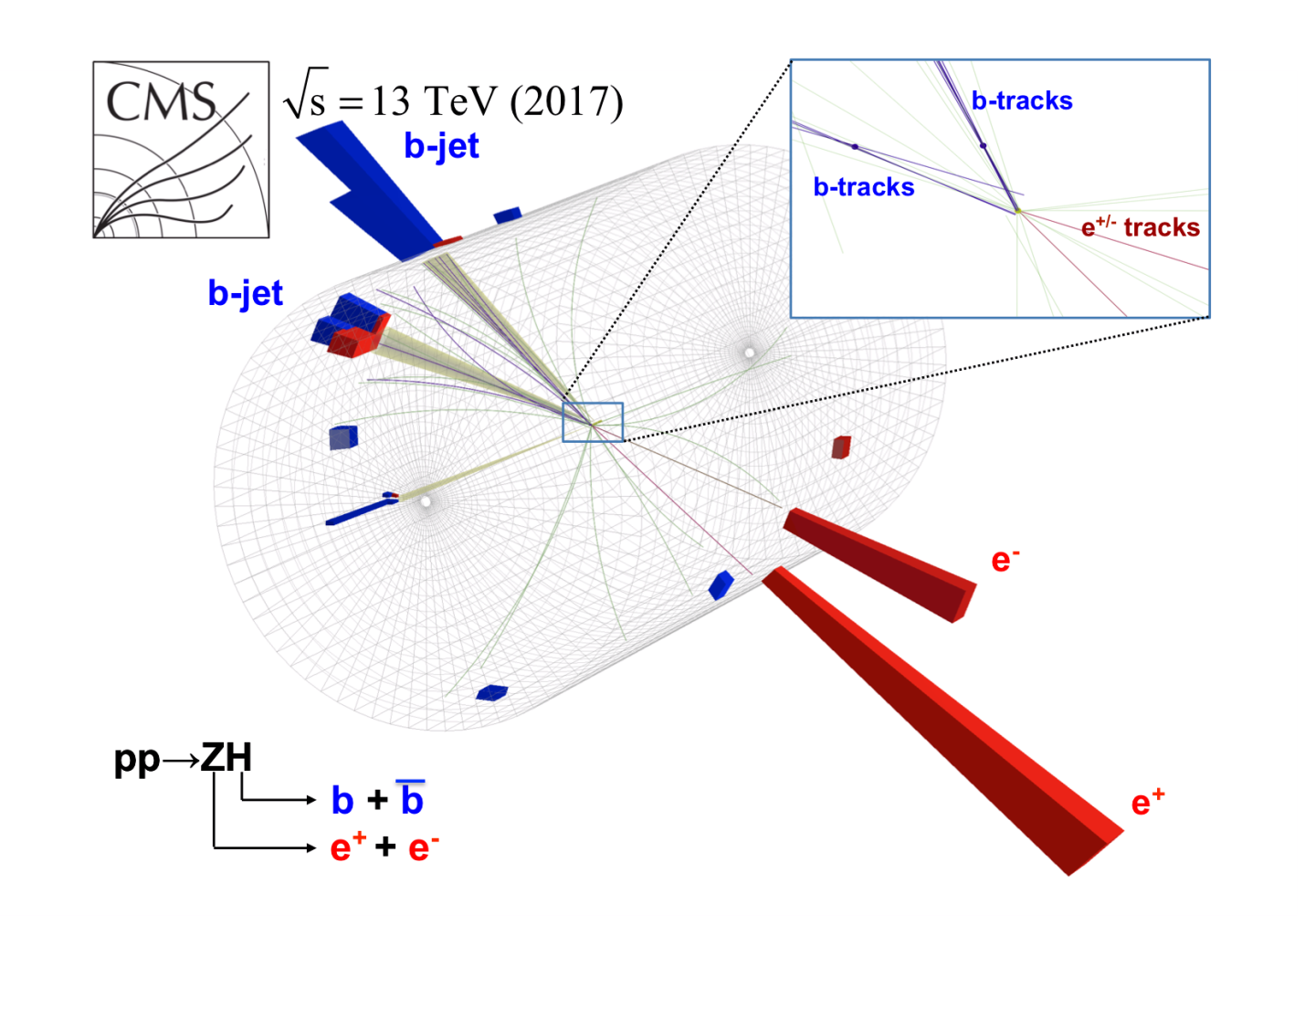
Fig. Candidate event showing the associated production of a Higgs boson and a Z boson, with the subsequent decay of the Higgs boson to a bottom quark and its antiparticle.

